# Functional Requirements

## Process specifications

Below are the specific process requirements needed for some of the use-cases:

### Signing In

Summary: On signing in, users will present their user id and password and the system will

validate them before signing them into the system and awarding them their privileges on the system.

Requirement needed for process: User id and password should be valid.

Basic Sequence: 1. – User enters user id and password.

2. – System validates user by checking user sign in details against the database.

3. – If the user is valid, sign the user into the system and display the appropriate

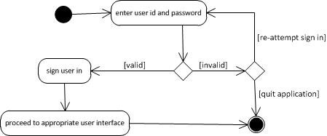user interface. If the user is invalid, reject sign in attempt and request user to re-attempt sign in or exit the application.

### Adding Lecturer to the system

Summary: The HOD shall be able to add a lecturer to the system, however this lecturer has to

be a valid lecturer at the university.

Requirement needed for process: Lecturer should be valid lecture at the university.

Basic Sequence: 1. – HOD will input lecturer id and details.

2. – System will confirm lecturer against university database.

3. – If lecturer is valid on university database, lecturer is added to the system along

with his/her module. If the lecturer is invalid, the HOD can either re-attempt or quit the process.

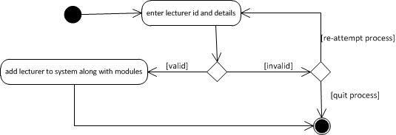

### Adding TA/Tutor to the system

Summary: Lecturers shall be able to add TAs and Tutors to the system. However these TAs and

Tutors need to be either valid students or lecturers (or employees) at the university.

Requirement needed for process: TA/Tutor is a valid student or lecturer (or employee) at the

university.

Basic Sequence: 1. – Lecturer attempts to add potential TA/Tutor to the system.

2. – System validates potential TA/Tutor against university student and employee

database.

3. – If potential TA/Tutor exists on the university database, TA/Tutor is added to the

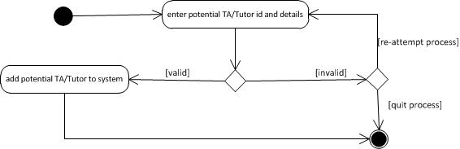system. If TA/Tutor does not exist on the database, the Lecturer may either re-attempt or quit the process.

### Locking and finalizing mark-sheet

Summary: Lecturers shall be able to lock and finalize mark sheets. However, this process is dependent on the actual marking session being completed. Hence the lecturer should not be able to lock a mark sheet while a marking session is in progress.

Requirement needed for process: Marking session should be complete.

Basic Sequence: 1. – Lecturer attempts to lock mark-sheet.

2. – If marking session is complete, mark-sheet is locked. If marking session in not complete, mark-sheet lock attempt fails, and lecturer may re-attempt until marking session is complete.

